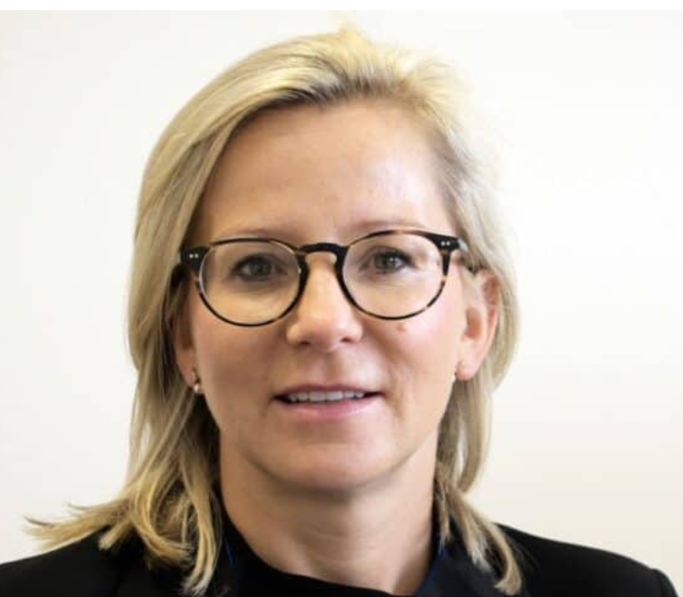

Dear Colleagues,

We are pleased to announce the appointment of Anna Walsh as Head of HR for Poland and Ukraine, effective 1st of September.

Anna is originally from Poland, where she also completed her studies, Anna brings extensive experience as a strategic HR leader with a strong track record of driving organizational transformation, operational excellence, and high-performing cultures across complex, multi-country environments. Currently serving as HR Director for Dublin site, she has played a pivotal role in shaping and delivering people strategies aligned with business priorities, while enhancing employee engagement and performance.

During her tenure as HR Director and a member of the Dublin site leadership team, she contributed significantly to the organisation achieving the Shingo Prize, Gold Certification from the Irish Centre for Diversity, and Great Place to Work recognition.

In her new role, Anna will lead the HR agenda across Poland and Ukraine, supporting business growth, strengthening organizational capability, and fostering an inclusive and high-performance culture across both markets.

We would also like to extend our sincere thanks to Nafsika for her leadership and commitment in successfully covering this role on an interim basis. Her contribution during this period has ensured continuity and strong support for the business.

Please join us in congratulating Anna on her new role and wishing her every success in this exciting next chapter.

Best regards,
Smahane KISSI
Regional HR Head EMM

Cyrille Debar
SVP HR International Operations

