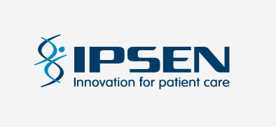
HR ANNOUNCEMENT
August 31st 2022
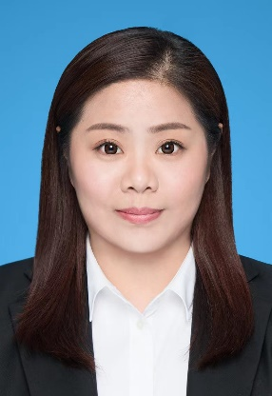

Dear colleagues,

I am pleased to announce the nomination of Kelly Zhao as Manager, Talent Acquisition Partner in Shanghai, China.

Kelly will directly report to me and dot line report to Christine Wang. She will work collaboratively to secure talent for our Chinese organisation.

Kelly has worked in Talent Acquisition since 2008, working initially in the IT Industry with Wicresoft and Dell, then joining the medical devices industry in Medtronic, where she progressed from Staffing Supervisor to TA Partner. She also worked in B. Braun. Most recently she has been HR Business Partner with Urgo Medical, working across Talent Acquisition and Business Partnering.

Kelly will be based with the Speciality Care team. She is Shanghai native, with a degree in Electronic Information Engineering and certification in Human Resources and in Interpretation.

Please join me to welcome Kelly. We wish her every success in her new role.

Caroline O’Reilly
Head of TA International &
Interim Head of TA UK&I

Christine Wang
HR Head of Cluster for China and APAC

