FESTIVAL OF LEARNING – SEPTEMBER 2021

At Ipsen, we learn and share every day. We encourage our people to continuously grow their personal and professional soft skills to boost a culture of collaboration and excellence.  Throughout September, we are celebrating the Festival of Learning - Have a Go Month in the UK.  The Festival of Learning is the biggest celebration of lifelong learning. The aim is to celebrate the benefits of lifelong learning, inspire more people to have a go at learning something new and to increase our curiosity.  Over the next few weeks, you can look forward to hearing more about what we are doing here at Ipsen to support employee learning.  We will BRING you suggestions on how you can BUILD your knowledge, BOOST your capabilities and ultimately DELIVER improved patient care.  We will be encouraging you to ‘Have a Go’ yourself by accessing some of the resources on offer through iLearn and iBenefits |  |  | 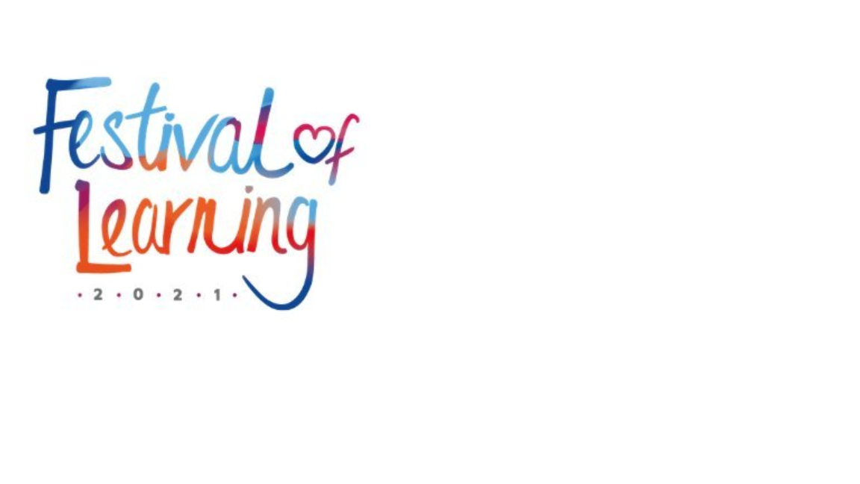  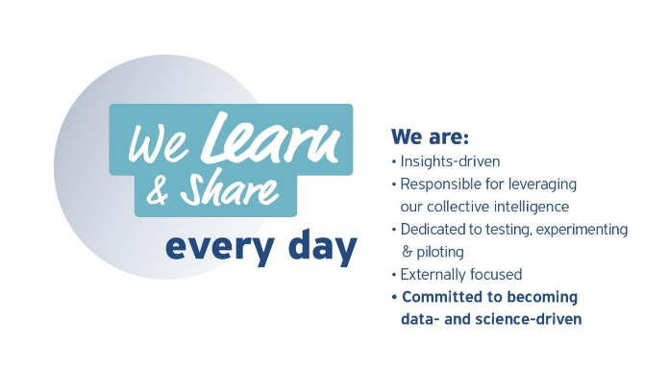
 | Leverage our Collective Intelligence  Share your learning experiences with your colleagues on Teams and Yammer.  Post using the using the hashtags #haveago and #welearnandshare

Theory of Marginal Gains.​​​
​​​​​​​Definition of marginal gains: The theory that small yet significant improvements can lead to monumental results.
Just think what could a 1% improvement each day mean for you and for our patients.......?

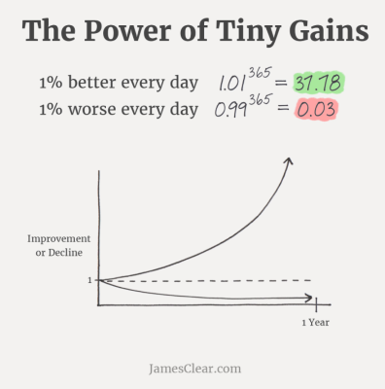 |  | To read the full article click here or to listen to Dave speak on the topic click here  “The whole principle came from the idea that if you broke down everything you could think of, that goes into riding a bike, and then improved it by 1%, you will get a significant increase when you put them all together.”  Sir Dave Brailsford



